|  |  |  |  |  |  |  |  |  |  |
| --- | --- | --- | --- | --- | --- | --- | --- | --- | --- |
| **]SCHOOL OF COMPUTER SCIENCE AND ARTIFICIAL INTELLIGENCE** | | | | | **DEPARTMENT OF COMPUTER SCIENCE ENGINEERING** | | | | |
| **ProgramName:**B. Tech | | | | **Assignment Type: Lab** | | | **AcademicYear:**2025-2026 | | |
| **CourseCoordinatorName** | | | | Venkataramana Veeramsetty | | | | | |
| **Instructor(s)Name** | | | | |  | | --- | | Dr. V. Venkataramana (Co-ordinator) | | Dr. T. Sampath Kumar | | Dr. Pramoda Patro | | Dr. Brij Kishor Tiwari | | Dr.J.Ravichander | | Dr. Mohammand Ali Shaik | | Dr. Anirodh Kumar | | Mr. S.Naresh Kumar | | Dr. RAJESH VELPULA | | Mr. Kundhan Kumar | | Ms. Ch.Rajitha | | Mr. M Prakash | | Mr. B.Raju | | Intern 1 (Dharma teja) | | Intern 2 (Sai Prasad) | | Intern 3 (Sowmya) | | NS_2 ( Mounika) | | | | | | |
| **rCourseCode** | | | 24CS002PC215 | **CourseTitle** | | AI Assisted Coding | | | |
| **Year/Sem** | | | II/I | **Regulation** | | R24 | | | |
| **Date and Day**  **of Assignment** | | | Week5- Wednesday | **Time(s)** | |  | | | |
| **Duration** | | | 2 Hours | **Applicableto**  **Batches** | |  | | | |
| **AssignmentNumber:9.3**(Present assignment number)/**24**(Total number of assignments) | | | | | | | | | |
|  | | | | | | | | | |
|  | | | | | | | | | |
|  | **Q.No.** | **Question** | | | | | | ***ExpectedTime***  ***to complete*** |  |
|  | 1 | Lab 8: Documentation Generation: Automatic documentation and code comments  **Lab Objectives:**   * To understand the importance of documentation and code comments in software development. * To explore how AI-assisted coding tools can generate meaningful documentation and inline comments. * To practice generating function-level and module-level docstrings automatically. * To evaluate the quality, accuracy, and limitations of AI-generated documentation. * To develop a small automated tool for documentation generation in Python..     **Lab Outcomes (LOs):**  After completing this lab, students will be able to:   * Apply AI-assisted coding tools to generate docstrings and inline comments for Python code. * Critically analyze AI-generated documentation for correctness, completeness, and readability. * Create structured documentation (function-level, module-level) following standard formats. * Design and implement a mini documentation generator tool to automate code commenting and docstring creation.   **Task Description#1 Basic Docstring Generation**   * Write python function to return sum of even and odd numbers in the given list. * Incorporate manual **docstring** in code with Google Style * Use an AI-assisted tool (e.g., Copilot, Cursor AI) to generate a docstring describing the function. * Compare the AI-generated docstring with your manually written one.   **Expected Outcome#1:** Students understand how AI can produce function-level documentation.  **Task Description#2 Automatic Inline Comments**   * Write python program for **sru_student** class with attributes like name, roll no., hostel_status and **fee_update** method and **display_details** method. * Write comments manually for each line/code block * Ask an AI tool to add inline comments explaining each line/step. * Compare the AI-generated comments with your manually written one.   **Expected Output#2:** Students critically analyze AI-generated code comments.  **Task Description#3**   * Write a Python script with 3–4 functions (e.g., calculator: add, subtract, multiply, divide). * Incorporate manual **docstring** in code with NumPy Style * Use AI assistance to generate a module-level docstring + individual function docstrings. * Compare the AI-generated docstring with your manually written one.   **Expected Output#3:** Students learn structured documentation for multi-function scripts  **Push documentation whole workspace as .md file in GitHub Repository**  **Note: Report should be submitted a word document for all tasks in a single document with prompts, comments & code explanation, and output and if required, screenshots** | | | | | | Week4 - Wednesday |  |

**Task Description#1 Basic Docstring Generation**

* Write python function to return sum of even and odd numbers in the given list.
* Incorporate manual **docstring** in code with Google Style
* Use an AI-assisted tool (e.g., Copilot, Cursor AI) to generate a docstring describing the function

.

* Compare the AI-generated docstring with your manually written one.

**Expected Outcome#1:** Students understand how AI can produce function-level documentation.

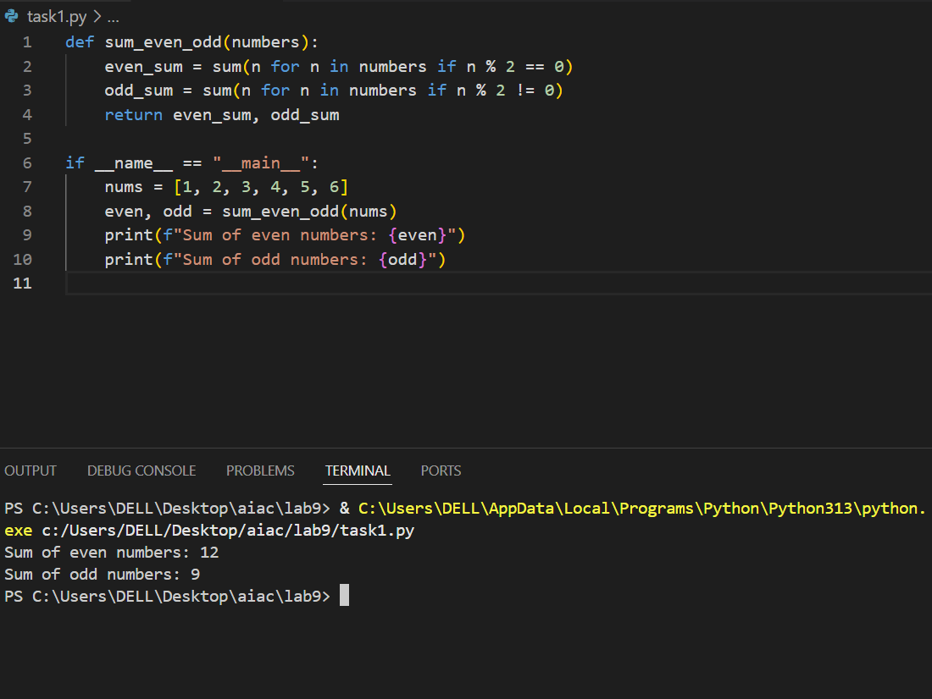

When you give this function a list of numbers, it looks through each one and separates them into two groups: even numbers and odd numbers. Then it adds up all the even numbers to get one total, and all the odd numbers to get another total. Finally, it gives you both results—first the sum of the even numbers, then the sum of the odd ones.

For example, if you pass in [1, 2, 3, 4, 5, 6], it will return (12, 9) because

The even numbers are 2, 4, 6= their sum is 12

The odd numbers are 1, 3, 5= their sum is 9

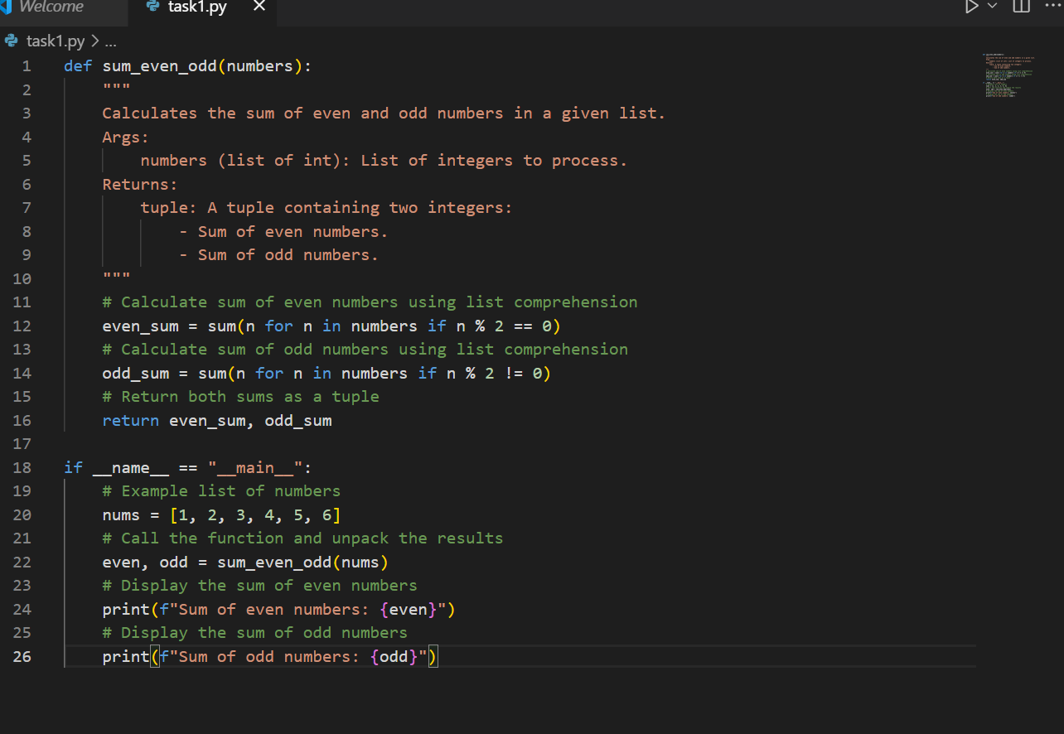

**Task Description#2 Automatic Inline Comments**

* Write comments manually for each line/code block
* Ask an AI tool to add inline comments explaining each line/step.
* Compare the AI-generated comments with your manually written one.

**Expected Output#2:** Students critically analyze AI-generated code comments.

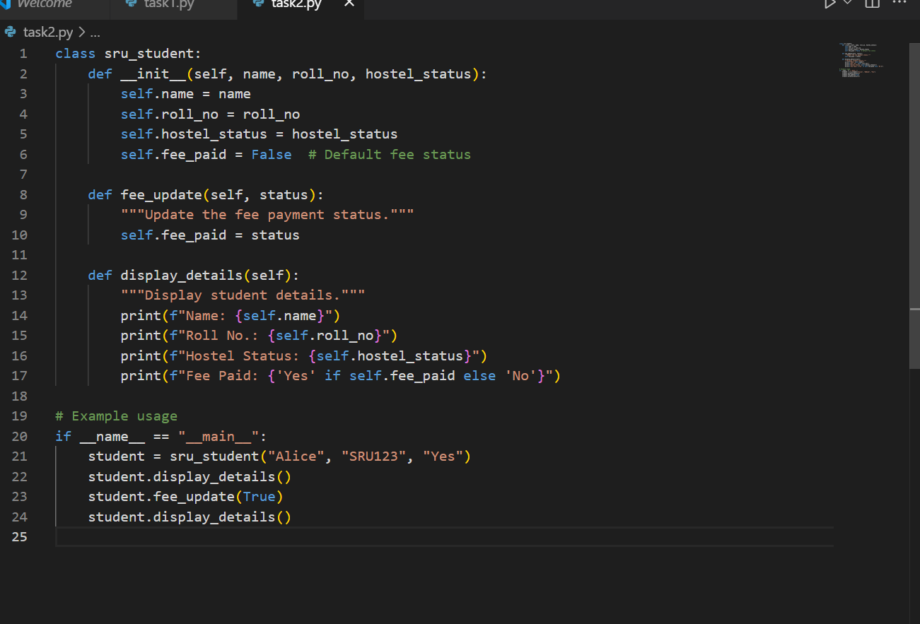

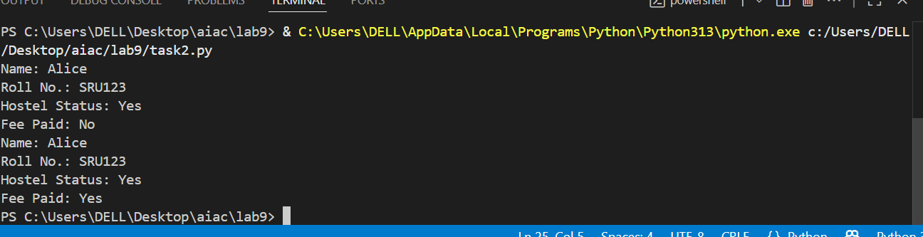

# using docstring

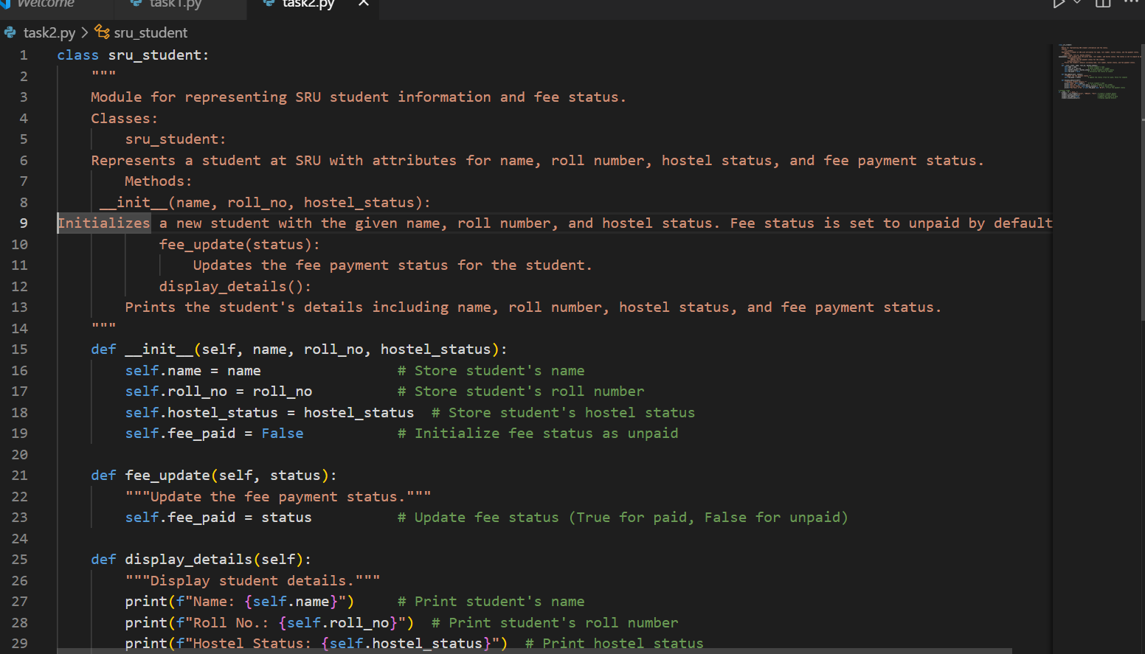

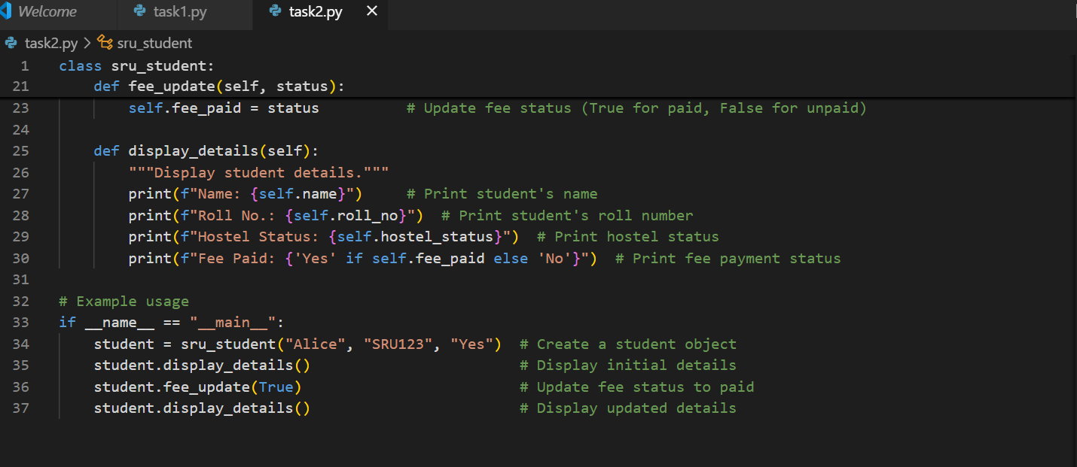

**Task Description#3**

* Write a Python script with 3–4 functions (e.g., calculator: add, subtract, multiply, divide).
* Incorporate manual **docstring** in code with NumPy Style
* Use AI assistance to generate a module-level docstring + individual function docstrings.
* Compare the AI-generated docstring with your manually written one.

**Expected Output#3:** Students learn structured documentation for multi-function scripts

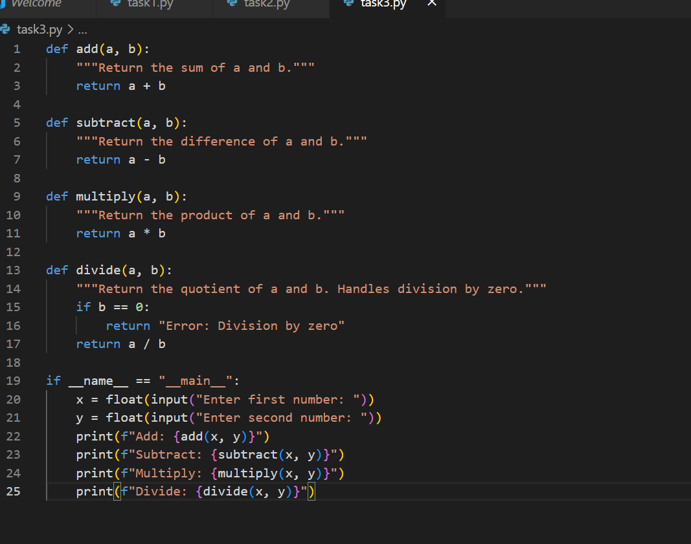

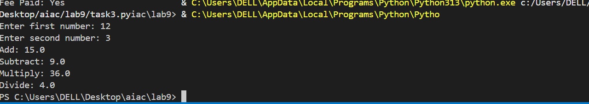

#using docstring

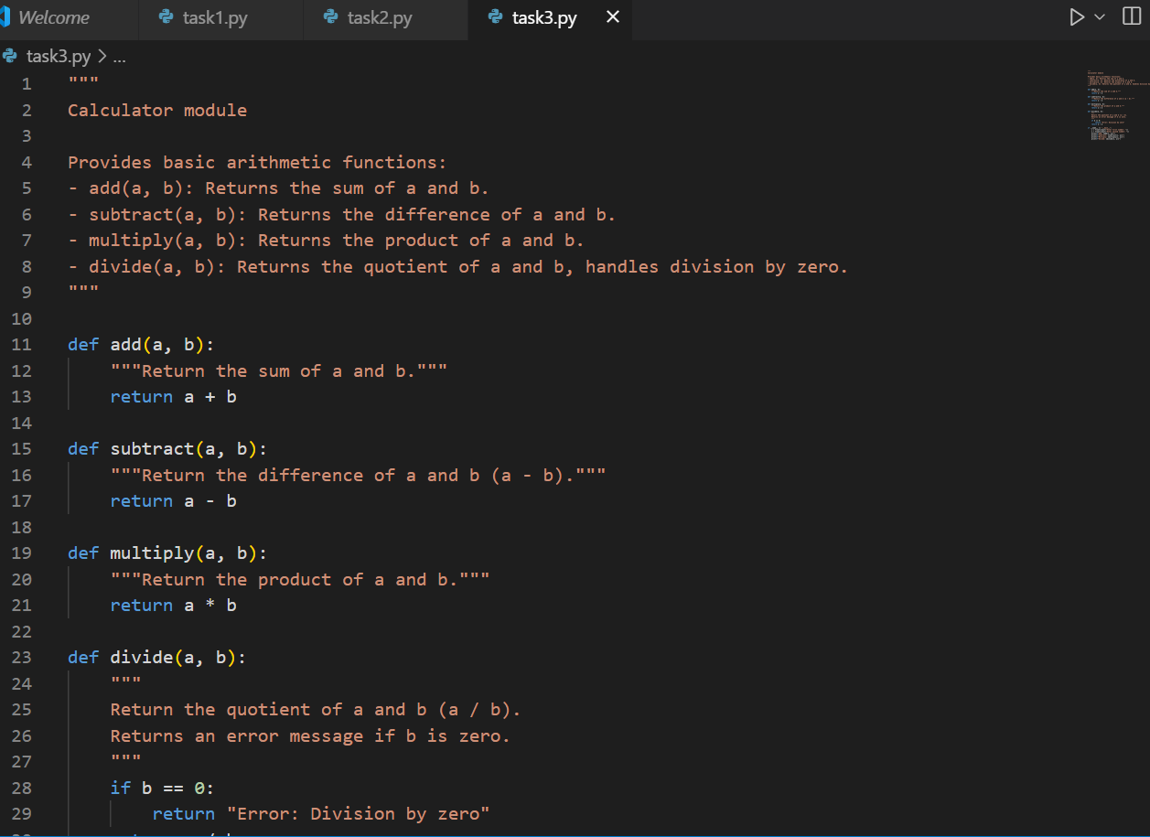

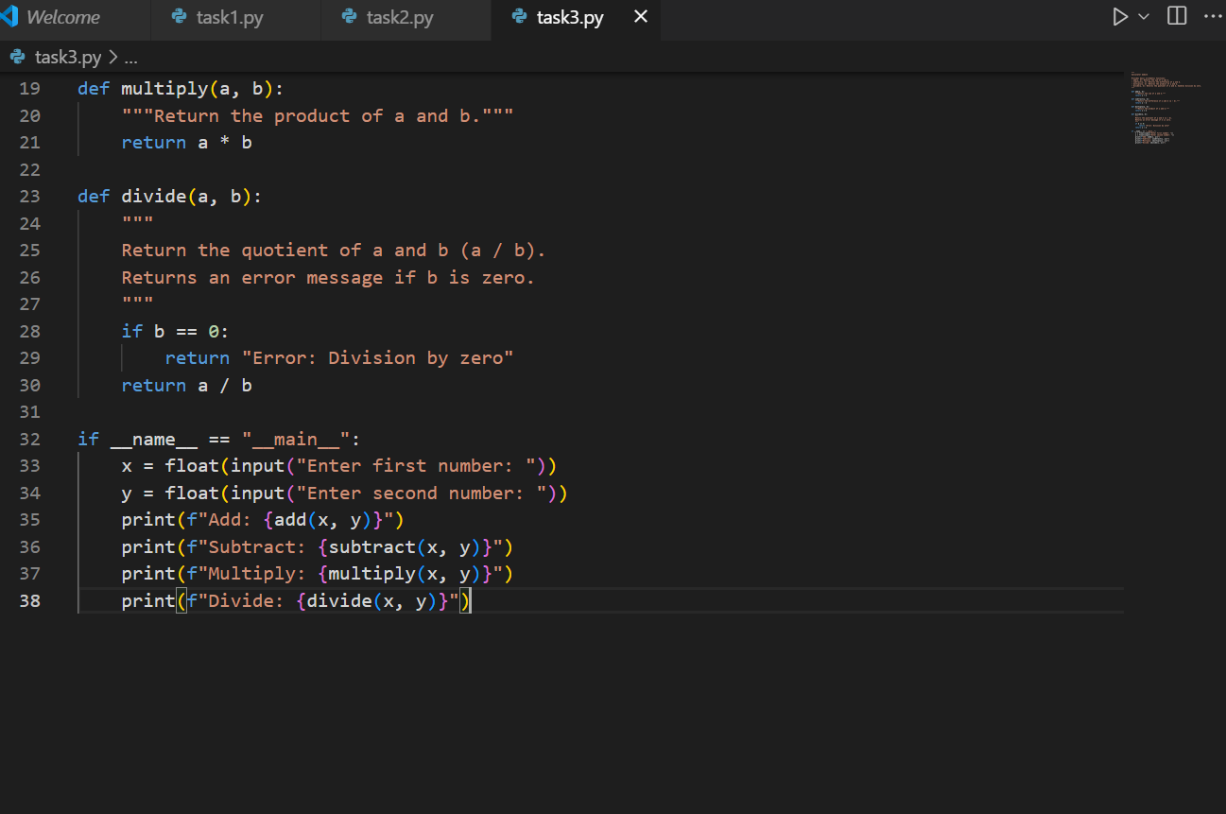

#individual function doc string:

